ESP32 Subcribe to NodeRed Message
Node red setup in browser
- Install Node Red (skip this if u already done install)
  - Install node js
  - Run command prompt and install Node Red
  - Run Node Red local server (do not close during using node-red)
  - Install palette dashboard @flowfuse/node-red-dashboard

- Open Node Red on browser
- Setup nodes as shown below

ESP32 , add 1 more LED
- Modify the nodes for Task 1 in Node Red
- Add the following nodes

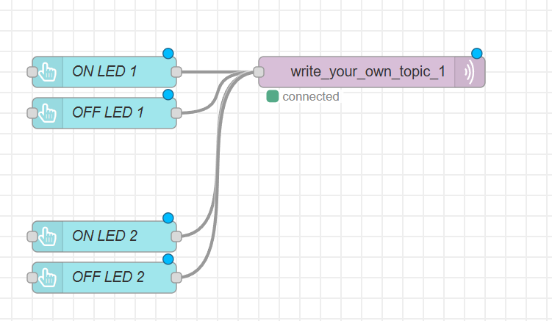

- Setup MQTT OUT
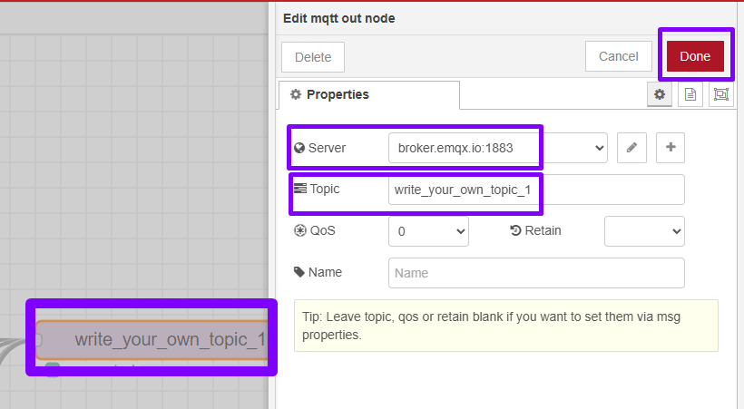

- Setup Button ON led 1
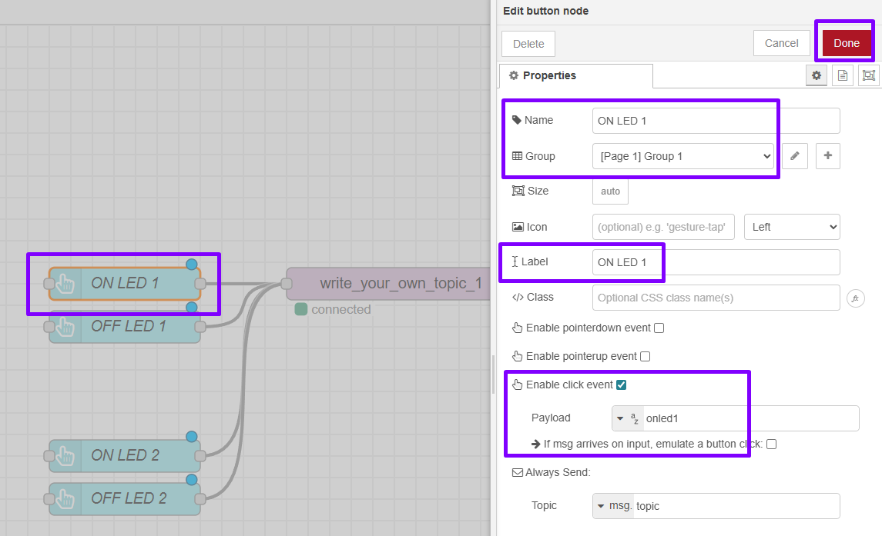

- Setup Button OFF led 1
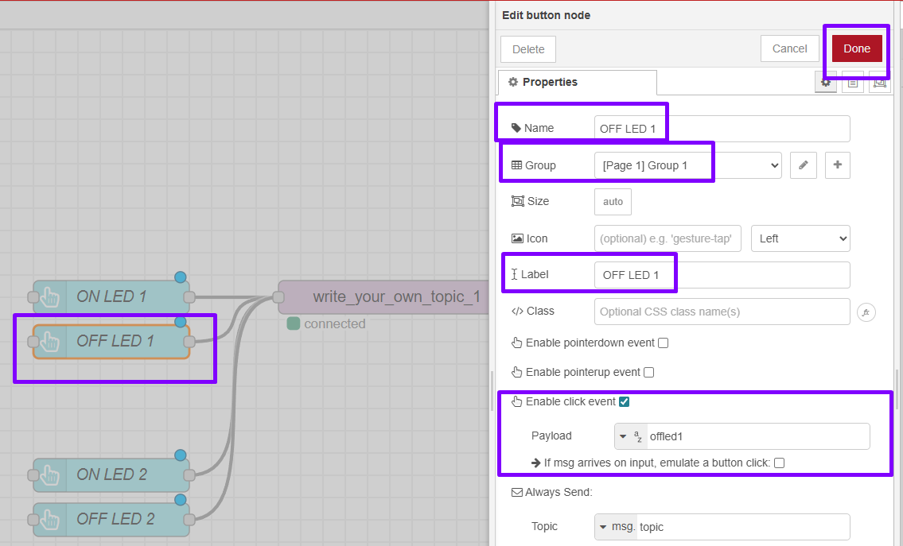

- Setup Button ON led 2
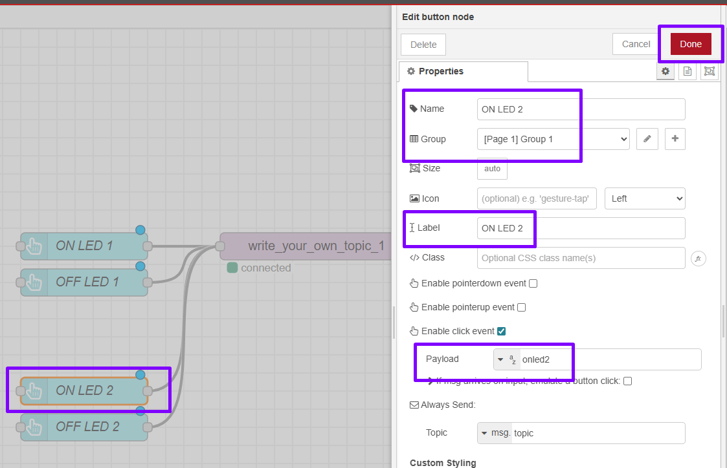

- Setup Button OFF led 2
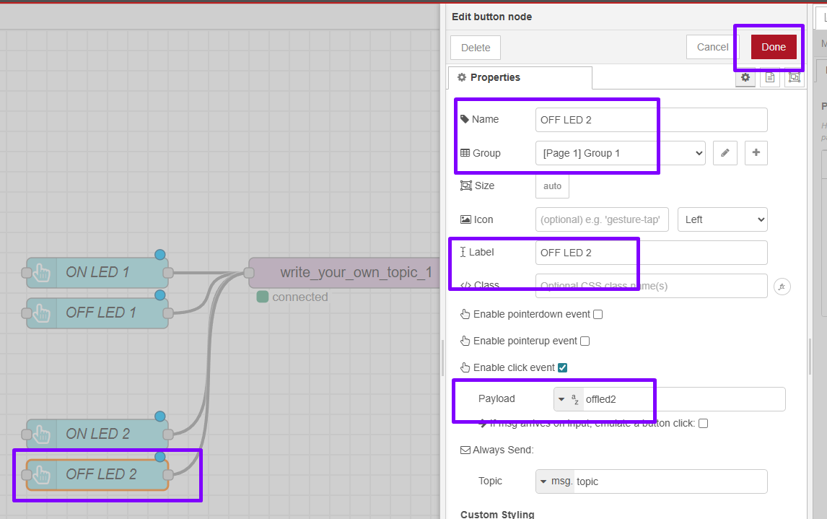

- After Setup is done,click deploy

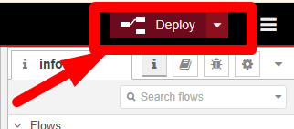

- Open dashboard
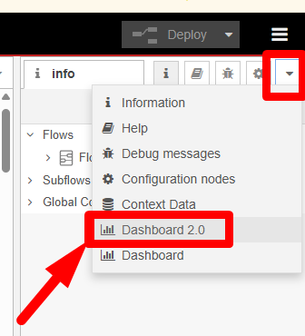

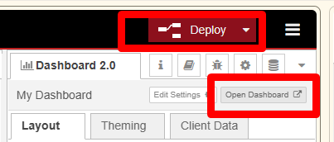

- The deployed dashboard in browser, is shown below.

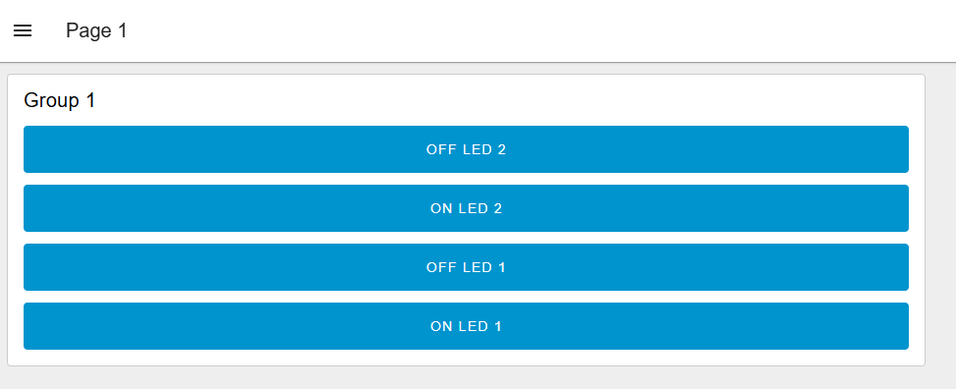

- Split and Arrange Buttons into Group
- Go to Right Tab, Click Dashboard 2.0, Layout, Pages

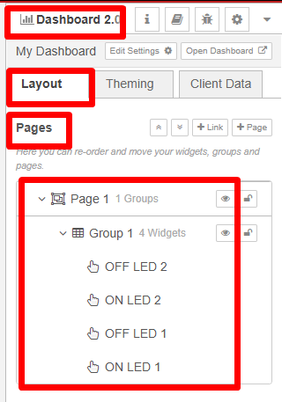

- Click Page 1 , click + symbol (Add Group)
- Rename LED 2
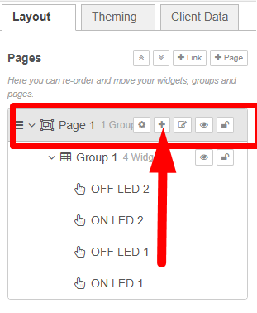

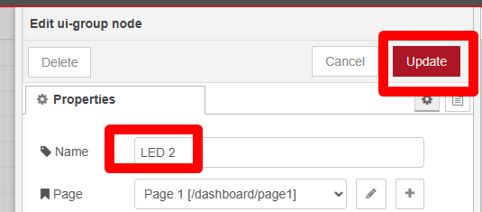

- You can rename,delete and set paramaeter by clicking gar button for each Group

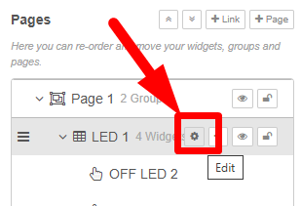

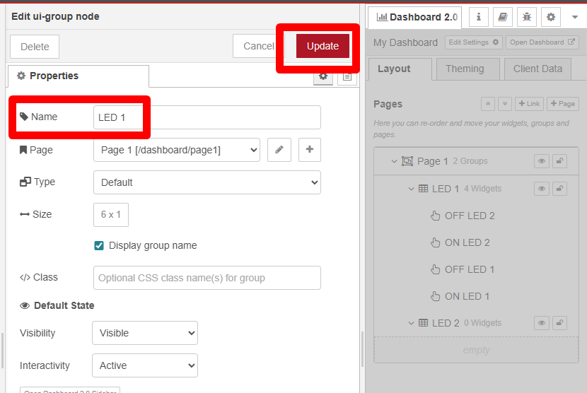

- Arrange the button for each LED Group
- To Arrange you can use Drag and Drop or Double Click on Node, and assign manually
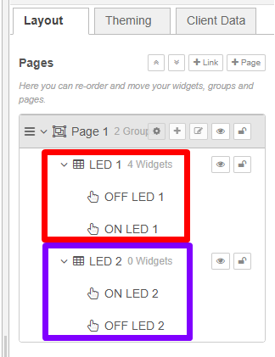

- Deploy again, after make any changes

- The deployed dashboard in browser, is shown below.

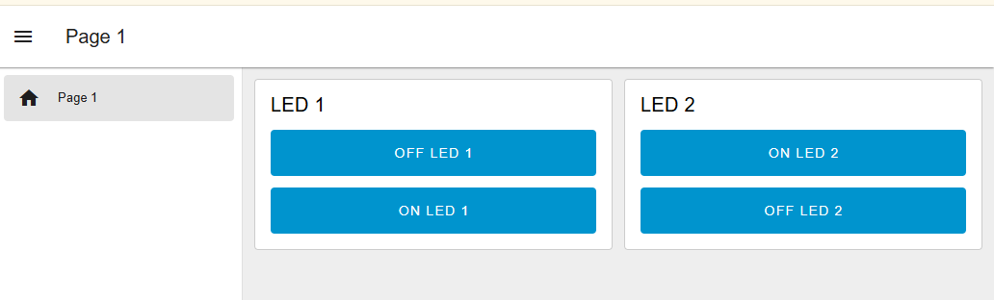

Circuit Setup using Hardware
- Connect the Hardware
- Refer the schematic diagram provided
- Check polarity and resistor value to make all will function properly

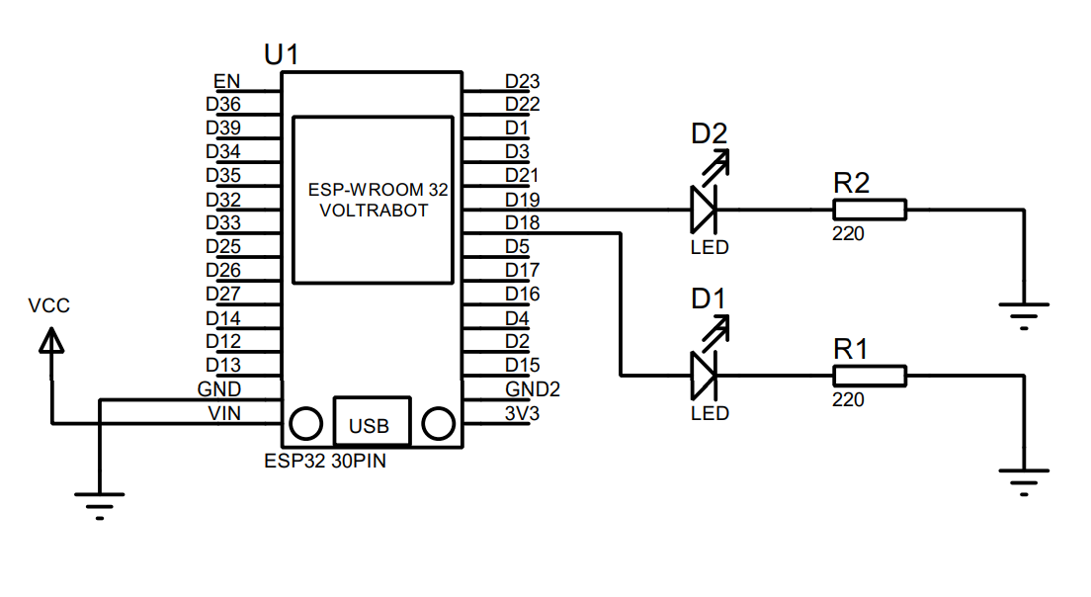
- Continue the setup for Arduino IDE

Setup codes in Arduino IDE
- Open Arduino IDE
- Copy code from this link : https://github.com/zulkeflipolimas/DEC30252-Student/blob/main/MQTT%20PreLab/mqtt_sub_2_LED.ino

- Modify the blank spot with suitable credential
  - Wifi SSID
  - Wifi Password
  - Broker Server (refer Node Red broker server link in MQTT OUT Nodes)
  - Subscribe Topic (refer Node Red topic in MQTT OUT Nodes)

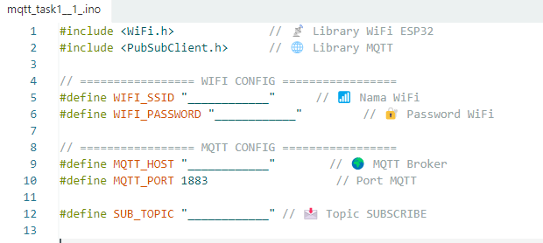

- Modify MQTT Callback mqttCallback() to setup incoming MQTT messages and controls LEDs based on received commands

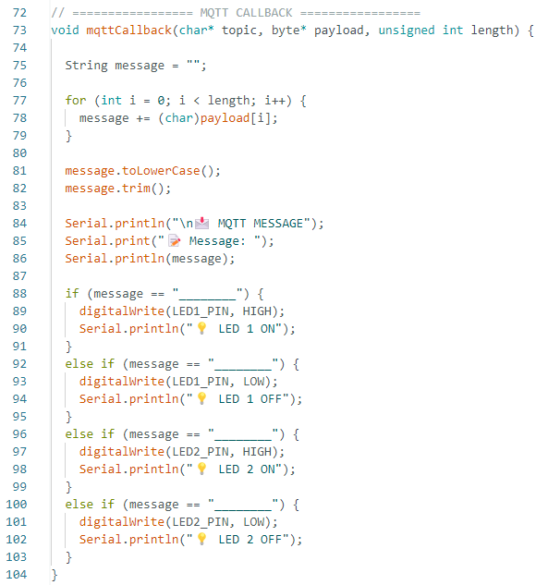

- The message must be the same with the Payload setting for each button in Node Red. Each payload message is unique for each button to avoid conflict.

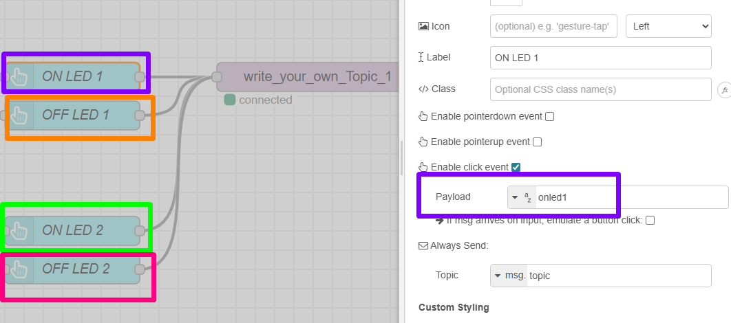

- After done setup wifi credential and the MQTT callback
- Upload the code to the ESP32 board. Wait for the upload to finish.
- Open the Serial Monitor in Arduino IDE.
- Set baud rate to 115200.
- Observe the ESP32 connecting to WiFi and the connecting to MQTT server

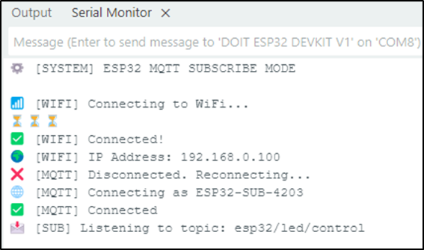

Testing Receiving and Processing MQTT message
- Test the ON button on Node Red deployed dashboard
  - Observe the ESP32 LED, the LED should turn ON
  - Observe the Serial Monitor:
    - The received topic and message should be displayed.
    - The LED status should be indicated as ON.

- Test the OFF button on Node Red deployed dashboard
  - Observe the ESP32 LED, the LED should turn OFF.
  - Observe the Serial Monitor:
    - The received topic and message should be displayed.
    - The LED status should be indicated as OFF.

Publish LED Status to Node Red

- Add UI LED for the second LED

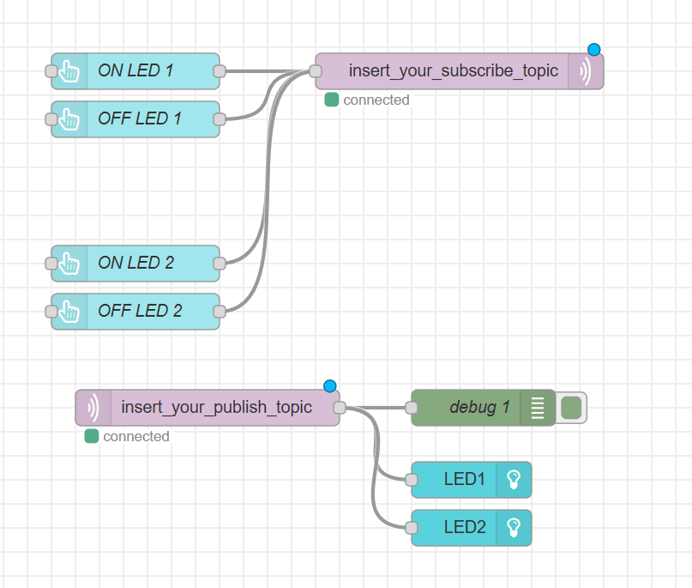

- Setup UI LED 1
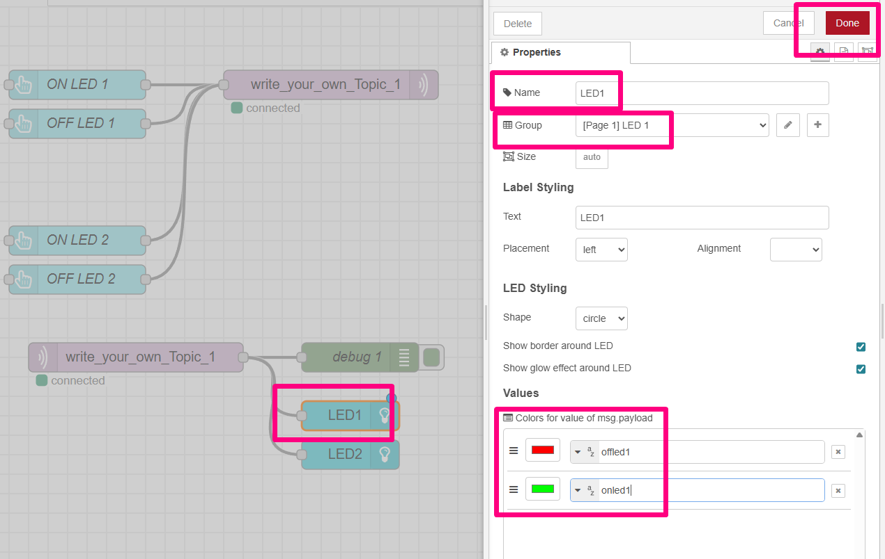

- Setup UI LED 2
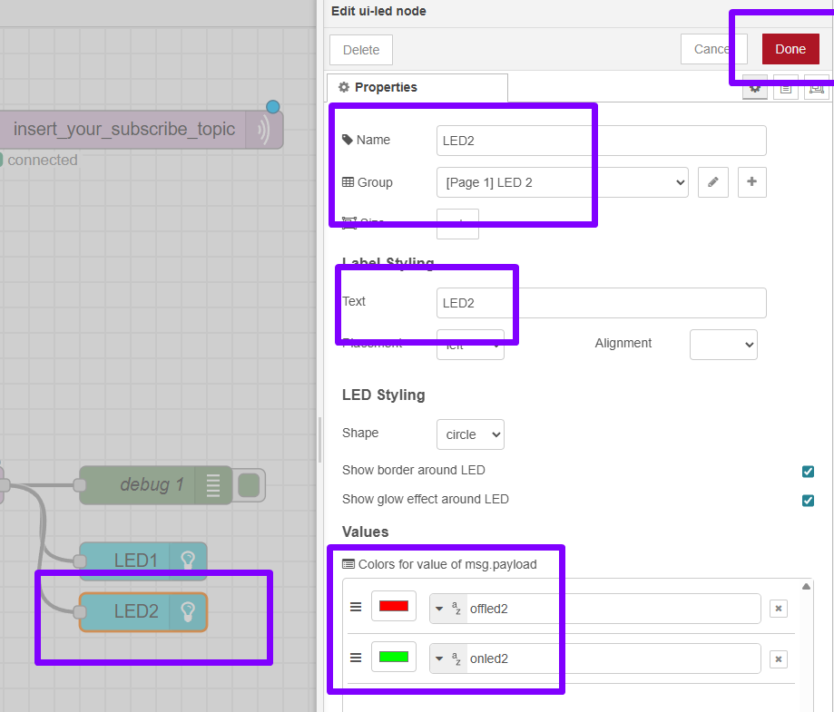

- Arrange, Label and deploy

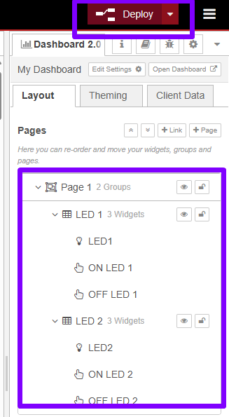

- Your deployed page will look like this
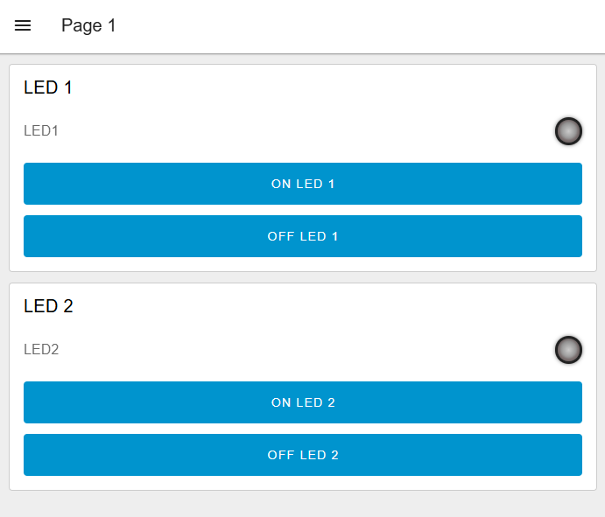

Setup codes in Arduino IDE

- Open Arduino IDE
- Copy code from this link : https://github.com/zulkeflipolimas/DEC30252-Student/blob/main/MQTT%20PreLab/mqtt_sub_pub_2_LED.ino
- Modify the blank spot with suitable credential
  - Wifi SSID
  - Wifi Password
  - Broker Server (refer Node Red broker server link in MQTT OUT Nodes)
  - Subscribe Topic (refer Node Red topic in MQTT OUT Nodes)
  - Publish Topic (refer Node Red topic in MQTT IN Nodes)

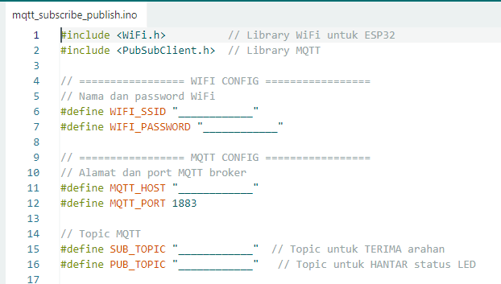

- Upload the code to the ESP32 board. Wait for the upload to finish.
- Open the Serial Monitor in Arduino IDE.
- Set baud rate to 115200.
- Observe the ESP32 connecting to WiFi and the connecting to MQTT server
- Observe the LED on ESP32 and Browser.

Receiving and Processing MQTT message
- Test the ON OFF button LED1 on Node Red deployed dashboard
  - Observe the ESP32 LED, the LED should turn ON
  - Observe UI LED on dashboard browser LED1
  - Observe the Serial Monitor:
    - The received topic and message should be displayed.
    - The LED status should be indicated as ON.

- Test the ON OFF button LED2 OFF button on Node Red deployed dashboard
  - Observe the ESP32 LED, the LED should turn OFF.
  - Observe UI LED on dashboard browser LED2
  - Observe the Serial Monitor:
    - The received topic and message should be displayed.
    - The LED status should be indicated as OFF.

- Verify the message payload receive by open Debug Window
  - Make sure when button pressed, the payload on or off is appear on debug window as shown below
  - Debug window can help u tracing the flow of data, payload and message during your code is running.
  - Its include time and date when payload/message received

